Primary Media Contact:  Advantech Co., Ltd.  Gabrielle Faeldan  Tel: 949-420-2500 ext. 226  gabrielle.faeldan@advantech.com |  |  | 2nd Media Contact:

Advantech Introduces New ARK-3500 Series
Fanless Embedded Box PCs with
Supreme Expansion, Extreme Performance

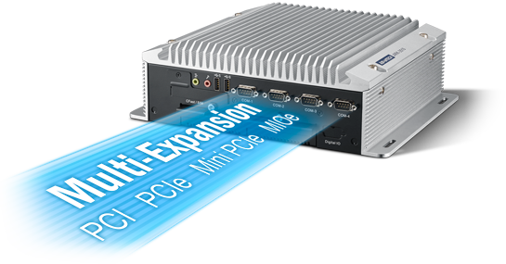
Feb 10, 2014, Irvine, CA – Advantech, a global leader in the embedded system market, is happy to announce the new ARK-3500 and ARK-3510 series of fanless embedded box PCs, which feature extreme performance and rich expansion. They are powered by 3rd generation Intel® mobile QM77, and support up to a Core™ i7 quad core processor. ARK-3500 series boasts versatile expansions – 2 PCI, PCIe x1, PCIe x4, MIOe module and 2 MiniPCIe to fulfill diverse applications. Complete storage options include 2 hard drives or SSD/ 2 mSATA/ Cfast, and there is also optional wireless communication Wi-Fi / 3G / GPS support. As for rugged design, ARK-35 series supports wide-range power input: 9~34V/ 12V DC, and wide operating temperature from -10 ~ 60° C with SSD. These new series provide complete EMC & Safety Certifications (CE/ FCC/ UL/ CCC/ CB/ BSMI). They combine all the benefits of performance, expansion, and storage in a single unit targeted toward a robust and compact computing platform involving machine automation, industrial plants, and cabinet integration.

Up to Quad Core Performance, Full Range of rPGA Processor Selection
ARK-3500 and ARK-3510 were designed to support rPGA socket type full range of processor selection from 3rd Generation / 2nd Generation Intel® Core™ i7 quad core, Intel® Core™ i5 , Intel® Core™ i3, to Intel® Celeron dual core processors up to 45W support with QM77 Panther Point Mobile PCH. Customers can choose their own 3rd or 2nd generation embedded or consumer processor based on different performance, price, and longevity demands. Graphic engine: Direct 11, OpenGL *3.1, OpenCL* 1.1 and Hardware decode acceleration: AVC/H.264, VC-1 and MPEG -2. These ARK units support 2 x DDR3 / DDR3L SODIMM memory slots up to 16GB, providing for your extreme performance targets!
High Expansion Flexibility for Diverse Applications
ARK-3500 provides dual expansion slots with 2 PCI or PCIe x1 + PCIe x4 interfaces. It is easily compatible with isolated AIO/DIO CAN card and motion control card for factory automation, camera link card for machine vision, and video capture card for surveillance. ARK-3510 features high flexibility with its optional MIOe module support for extended I/O. It can offer six different SKUs for different applications, such as adding an MIOe-220 module for up to a total of 5 GigaLAN ports, which can serve as a data backup and transfer station. Both ARK-3500 and ARK-3510 can support 2 more MiniPCIe interfaces with 2 SIM holders, and can support Wi-Fi, 3G, LTE 4G, GPS modules for wireless connectivity.

Rugged and Reliable Design for Harsh Environments:
ARK-3500 and ARK-3510 come equipped with a superior thermal design to ensure high system reliability; they support -10 ~ 60° C operating temperature w/ SSD, even running an Intel® Core™ i7 quad core processor without throttling. With lockable connectors on power, DVI, HDMI, COM, DIO, HDD bays, and expansion slots, the reliable mechanical design of ARK-3500 and ARK-3510 can support 3G vibration and 50G shock during operation with SSD.

Built-in SUSIAccess, Smart Remote Management Software and Intel® AMT 8.0 Technology
Advantech’s SUSIAccess software provides a smart, easy, remote management API so users can monitor, configure, and control a large number of terminals with centralized, real-time maintenance capability. This allows customers to focus on their applications while SUSIAccess helps manage administration. ARK-3500 and ARK-3510 series are also equipped with McAfee® for enhanced security and Acronis® for backup and recovery; these are official licenses, which protect your devices from threat.
ARK-3500 and ARK-3510 support iManager F/W technology - an intelligent, cross-platform, self-management tool that monitors system status and takes automatic action if anything is abnormal. iManager provides multi-level programmable watchdogs including IRQ interrupt, ACPI events, reset levels, and can also monitor voltage and temperature to ensure system reliability!
ARK-3500 and ARK-3510 series also support Intel® AMT 8.0 Technology built-in security for greater protection. First is threat management, including protection from rootkits, viruses, and malware. Second is identity and website access point protection, along with confidential personal and business data protection. Third, remote and local monitoring, remediation, and repair of PCs and workstations.
Features:
ARK-3500
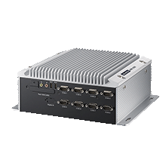
with 2 Expansion Slots and 9-34V Wide Range Power
- Supports Intel® Core™ i3/i5/i7 mobile processor(rPGA) + Intel® QM77 PCH
- DDR3/DDR3L SO-DIMM up to 16 GB
- Triple independent display with 3rd gen Core i processor : DVI + HDMI + DisplayPort
- 2 PCI, PCIe x1 & PCIe x4 expansion slots, 2 x miniPCIe with SIM holders
- 9-34V wide range lockable DC jack design
- 2 Intel® GbE/ 4 USB3.0/ 2 USB2.0/ 8 COM Flexible Storage Support : 2x 2.5" SATA HDD/ SSD bays (RAID 0, 1), 2x mSATA and 1x CFast
- Dimensions: 290 x 110 x 232mm
- Supports iManager, SUSIAccess and Embedded Software APIs

ARK-3510
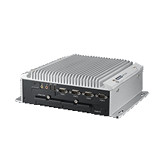
with 2 x 2.5" Removable HDD Bays, MIOe Supported
- Supports Intel® Core™ i3/i5/i7 mobile processor (rPGA) + Intel® QM77 PCH
- DDR3/DDR3L SO-DIMM up to 16 GB
- Triple independent display with 3rd gen
Core™ i processor : DVI + HDMI + DisplayPort
- Supports 2 x 2.5" removable SATAIII drive bays (RAID 0, 1) , 2x mSATA and 1x CFast
- MIOe expansion module supported, 2 x miniPCIe with SIM holders
- 2 Intel® GbE/ 4 USB3.0/ 2 USB2.0/ 4 COM
- Lockable 12V DC jack design (9~34V by option)
- Dimensions: 290 x 90 x 232mm
- Supports iManager, SUSIAccess and Embedded Software APIs

For more information about ARK-3500 and ARK-3510, please contact your local sales office, or visit us on the web at: http://www.advantech.com/products/ARK-3300-Series/sub_1-2JKD2D.aspx

About Embedded Core Service
Advantech Embedded Core Services offers design-in oriented services. These streamlined solutions broadly integrate embedded boards, peripheral modules and software. This dedicated focus on Embedded Design-in services fulfills electronic engineering demands at their design-in phase, and brings benefits that shorten the design and integration cycle, minimizing uncertainty and risk. www.advantech.com/EmbCore

About Advantech
Founded in 1983, Advantech is a leader in providing trusted, innovative products, services, and solutions. Advantech offers comprehensive system integration, hardware, software, customer-centric design services, embedded systems, automation products, and global logistics support. We cooperate closely with our partners to help provide complete solutions for a wide array of applications across a diverse range of industries. Our mission is to enable an intelligent planet with Automation and Embedded Computing products and solutions that empower the development of smarter working and living. With Advantech, there is no limit to the applications and innovations our products make possible. (Corporate Website: www.advantech.com).

