Primary Media Contact:  Advantech Corp.  Edna Garcia  Tel: 949-420-2500, Ext. 134  ednag@advantech.com |  |  | 2nd Media Contact:
Advantech Mini-ITX COM Express Type 6 Application Board With Extended Temperature Support
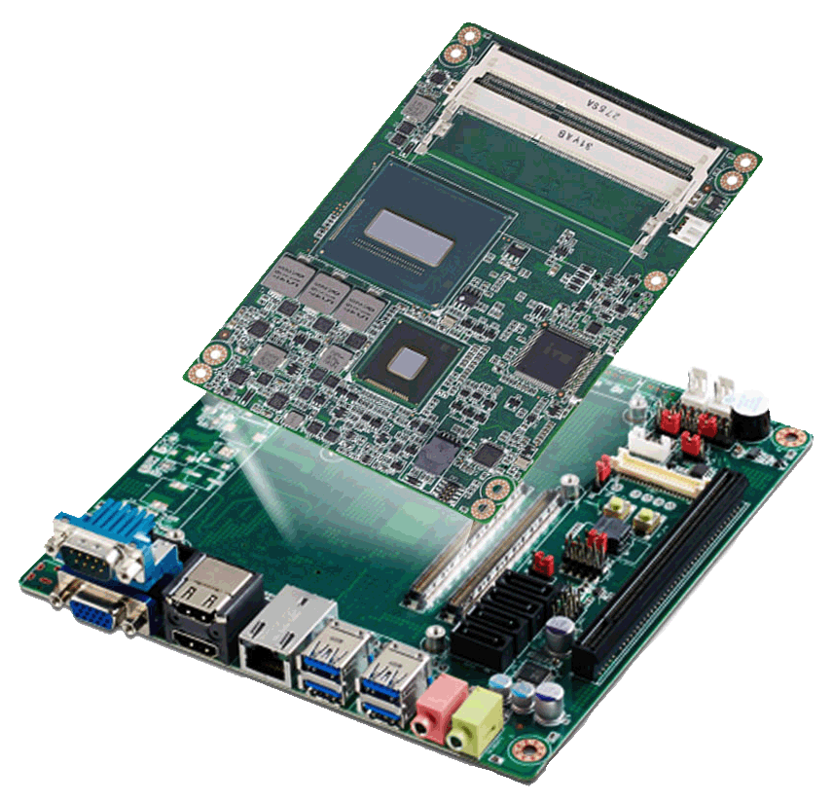
May 20, 2014, Taipei - Advantech, a leading embedded computing solution provider, announces the release of its newest Mini-ITX application board—SOM-AB5810. Featuring pin to pin compatibility with COM Express® Basic and Compact type 6 pin-out CPU modules, SOM-AB5810 supports both normal and wide-range temperature demands, as well as ATX power supply and optional DC-in adapter. SOM-AB5810 is ideal for harsh environments and perfect for outdoor surveillance, industrial automation, digital signage, kiosk applications and much more.

Scalability And Extreme Temperature Requirements
SOM-AB5810 is designed to interlock with performance COM Express® Basic and Compact type 6 pin-out CPU modules to provide a range of choices for customers. Compatible Advantech CPU models include SOM-5892 with 3rd Gen. Intel® Core™, SOM-5894, and SOM-6894 with 4th Gen. Intel® Core™. Based on the COM-Express® architecture, these modules offer high scalability for platform upgrades in the future, and cost effective protection for customers concerned about their confidentiality. Better yet, to achieve extended temperature requirements, all the components on SOM-AB5810 are screened and are validated for normal and wide-range working temperature operation. This gives customers more options when they design their Mini-ITX projects with these environment in mind.

Alternative Power Design & I/O Interface
SOM-AB5810 is designed for ATX power supply and optional DC-in via an adapter. ATX power supply can deliver under 47W to the CPU module board (Note: ATX power supply should be more than 200W). For the optional DC-in adapter power design, it can deliver under 17W to the CPU module. For the I/O interface, SOM-AB5810 supports standard and low profile design types. The standard I/O interface fits with a standard Mini-ITX I/O shielding and standard Mini-ITX chassis without alterations. The low profile I/O interface can meet both standard I/O shielding or customized interface within a low profile chassis design.

Reinforced with Advantech iManager 2.0 & SUSIAccess
Remote management is becoming more and more important for customer’s applications. Advantech’s compact or basic CPU modules for SOM-AB5810 are preloaded with Advantech's SUSIAccess remote device management software and iManager firmware self-management tool, which provides an invaluable suite of programmable APIs such as multi-level watchdog timer, hardware monitoring, and many other intelligent tools that can add greater value to your applications. iManager on chip self-mangement agent ensures the system operates normally even when the OS crashes, helping enhance system stability, compatibility, and reducing effort on carrier board design and platform migration.

SOM-AB5810, along with SOM-5892 COM Express® Basic CPU module will be available in May 2014. SOM-AB5810, along with SOM-5894 will be ready in Q3 2014, and SOM-AB5810, along with SOM-6894 will be ready in Q4 2014. Please contact your local Advantech sales rep or visit the website (http://www.advantech.com.tw/embcore/) for more details.

SOM-AB5810 Features:
- Supports standard ATX power and optional DC-in models
- Supports 1 x VGA, 1 LVDS, 2 HDMI
- Supports 1 x PCIe x16 (ATX SKU), 1 x PCIe x1 (DC-in SKU), 4 SATA (ATX SKU), 2 SATA (DC-in SKU), mSATA (for optional), 2 mini-PCIe, 1 LAN, 4 USB 3.0, 2 USB 2.0, and 2 COM ports
###
About Embedded Core Service
Advantech Embedded Core Services offers design-in oriented services. These streamlined solutions broadly integrate embedded boards, peripheral modules and software. This dedicated focus on Embedded Design-in services fulfills electronic engineering demands at their design-in phase, and brings benefits that shorten the design and integration cycles, minimizing uncertainty and risk. www.advantech.com/EmbCore

About Advantech
Founded in 1983, Advantech is a leader in providing trusted, innovative products, services, and solutions. Advantech offers comprehensive system integration, hardware, software, customer-centric design services, embedded systems, automation products, and global logistics support. We cooperate closely with our partners to help provide complete solutions for a wide array of applications across a diverse range of industries. Our mission is to enable an intelligent planet with Automation and Embedded Computing products and solutions that empower the development of smarter working and living. With Advantech, there is no limit to the applications and innovations our products make possible. (Corporate Website: www.advantech.com).

