Primary Media Contact:  Advantech Corp.  Edna Garcia  Ph: 949-420-2500, Ext. 134  ednag@advantech.com |  |  | 2nd Media Contact:
Highly Secure Advantech AIMB-503 MicroATX
with Rich I/O for ATMs and KIOSKs
Featuring Remote Management and Security Powered by SUSIAccess

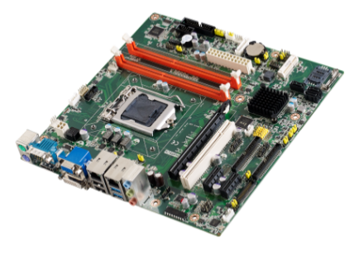
July 1, 2014, Irvine, CA – Advantech, the embedded platform and integration services provider today introduced AIMB-503, a new industrial-grade MicroATX motherboard embedded with the 4th generation Intel® Core™ i processor, providing better graphic and computing performance. Equipped with abundant I/O, AIMB-503 also enables extended connectivity to handle multiple peripherals. Integrated with the new SUSIAccess 2.0 Pro remote device management software, AIMB-503 can fulfill the essential demands in the ATM/KIOSK market, such as remote control, security, and system recovery.

Maximum connectivity for minimum resources
AIMB-503 comes with high connectivity and expansion options including: one PCI x16 expansion slot, two PCIe x1 expansion slot, 1 PCI slots, one Mini-PCIe with SIM card holder, 10 x serial ports, 3 x SATA III/II 600/300 MB/s connectors, 2 x USB 3.0 ports, 7 x USB 2.0 ports, keyboard/mouse port, and supports 8-bit digital programmable I/O along with two BTX type Audio Jacks. Both 11 x USB & 10 x serial ports can provide sufficient connection possibilities for KIOSK/ATM system integrators to link and manage multiple peripherals. All this connectivity is packed into a space-saving, power-efficient, and cost-effective MicroATX form factor.
Dual display and excellent graphics performance
Powered by the 4th generation Intel® Core i processors, AIMB-503’s dual display output supports DP+DVI, VGA+DP, VGA+DVI, (LVDS supports 3.3V, 5V, and 12V for large sized panels), which makes it suitable for integration with panel PC solutions, and also supports dual channel 48-bit LVDS for large sized panels. With Intel® HD graphics 5000 integrated onto the processor chip, this two-chip solution provides better 3D and video performance to deliver stunning graphics and imaging.

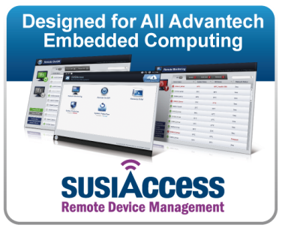
Remote device management –SUSIAccess Pro V2.0
AIMB-503 is pre-loaded with SUSIAccess Pro 2.0 providing intelligent remote device management and monitoring. With SUSIAccess Pro 2.0 on your device you can remotely switch machines on and off, access the desktop, recover a system and configure protection features. SUSIAccess Pro 2.0 includes McAfee’s banking-level security for system protection. With Acronis' No.1 backup and disaster recovery data protection solution on AIMB-503, you can confidently access your data anytime, anywhere. AIMB-503 with SUSIAccess Pro V2.0 is not only an industrial motherboard but also a solution kit which offers security, remote management, fast boot up, robust operation, rich I/O and multiple display features for any ATM/KIOSK applications.

Integrated intelligent software API
Supported Operating Systems include Windows 7, Windows 7 Embedded, Windows 8 hardware drivers for all these OS are readily available.

AIMB-503 Features
- Supports Intel® 4th generation Core™ i processors
- Two 240-pin DIMM up to 16 GB DDR3 1600 MHz SDRAM
- Supports dual display: DP+DVI, VGA+DP, VGA+DVI
- Rich I/O & expansion options: 10 x COMs, 2 x USB 3.0, 7 x USB 2.0, and 8-bit GPIO, 2 PCIe x1, 1 PCIe x16, 1 PCI,1 Mini PCIe
- Dual channel 6W amplifier for Audio
- Embedded value added software: SUSIAccess, Acronis, McAfee supported for remote management, remote system recovery, and banking-level security for system protection.

AIMB-503 is available now, for more information, please contact an Advantech local sales office.

About Embedded Core Service
Advantech Embedded Core Services offers design-in oriented services. These streamlined solutions broadly integrate embedded boards, peripheral modules and software. This dedicated focus on Embedded Design-in services fulfills electronic engineering demands at their design-in phase, and brings benefits that shorten the design and integration cycle, minimizing uncertainty and risk. www.advantech.com/EmbCore

About Advantech
Founded in 1983, Advantech is a leader in providing trusted, innovative products, services, and solutions. Advantech offers comprehensive system integration, hardware, software, customer-centric design services, embedded systems, automation products, and global logistics support. We cooperate closely with our partners to help provide complete solutions for a wide array of applications across a diverse range of industries. Our mission is to enable an intelligent planet with Automation and Embedded Computing products and solutions that empower the development of smarter working and living. With Advantech, there is no limit to the applications and innovations our products make possible. (Corporate Website: www.advantech.com).

