Primary Media Contact:
Advantech Corporation
Gabrielle Faeldan
Tel: 949-420-2500 ext.226
Gabrielle.Faeldan@advantech.com

Advantech Releases a Series of Embedded I/O Modules with MiniPCIe Interface for Fast I/O Extension
April 25, 2014, Irvine, CA – Advantech, a global leader in the IoT embedded market, is glad to announce a series of new Embedded I/O Modules for Touch, CANBus, Parallel, Serial, GigaLAN, SATA III, and USB 3.0 using standard full-size MiniPCIe interface. Using this standard design, customers can simply extend extra interface ports without board modification and easily integrate with their solutions to fulfill a diverse range embedded applications for Industrial PC, Embedded, Transportation, Automation, and Networking Infrastructure systems.
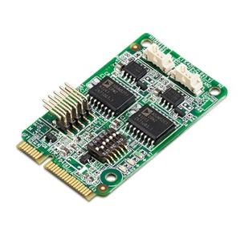
CANBus Port Module- EMCB-200U
Advantech EMCB-200U CANBus module is a high-quality electronic component developed and manufactured according to the CAN network standard. The form factor of EMCB-200U CANBus module is designed as a full-size Mini PCIe & module type combo solution.
For CANBus modules, Advantech has developed a series of APIs for customers to access CAN protocols. Meanwhile, CANOpen which is license based protocol, is also released with the CANBus modules as an alternative option.
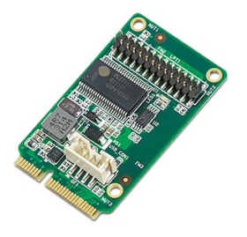
Parallel Port Module- EMIO-100P
Advantech EMIO-100P, USB to Parallel Printer port module, is a high-quality electronic component developed and manufactured according to the IEEE 1284 parallel printer port standard. Fully USB 1.1 compliant, the adapter supports bi-directional parallel interface communications.

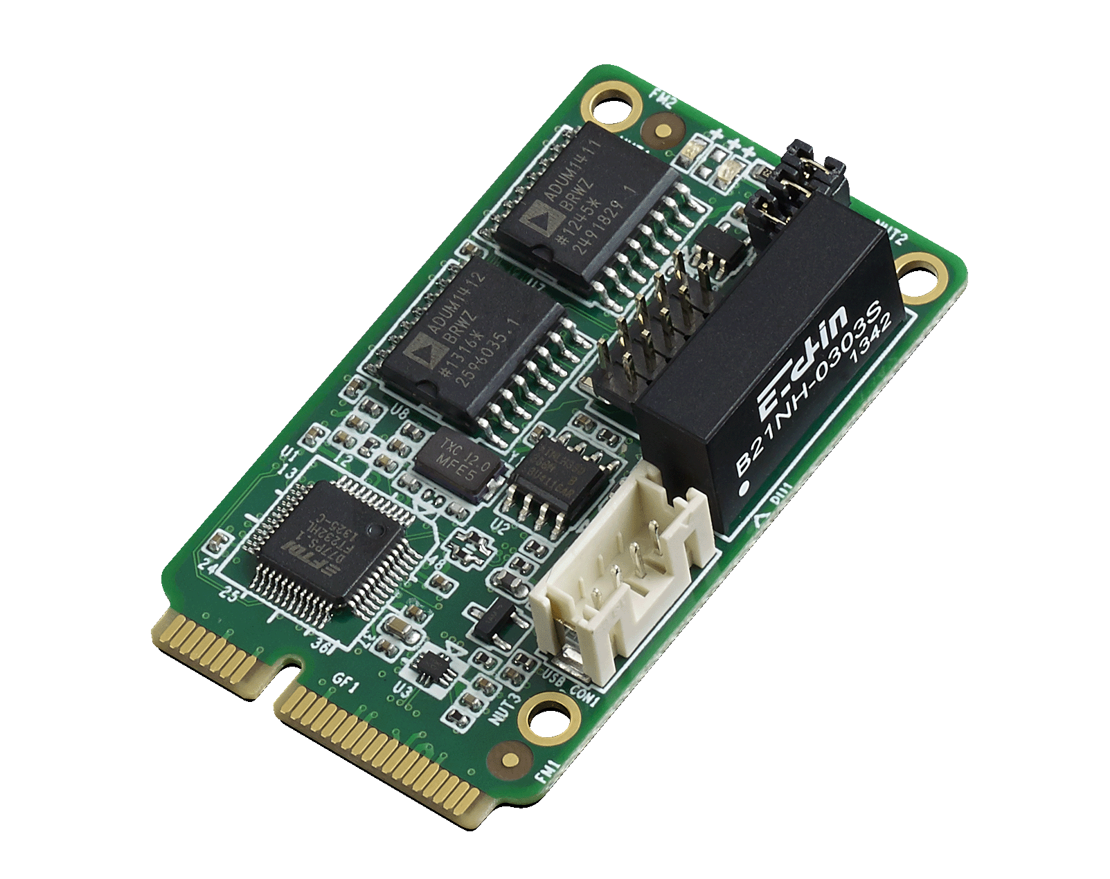
High-Speed Serial COM Module- EMIO-100S
EMIO-100S, USB to High-Speed Serial port module, is a high-quality electronic component developed and manufactured by Advantech. Fully USB 2.0 compliant, the adapter supports bi-directional serial interface communications.

EMCB-200U, EMIO-100P and EMIO-100S are available now. Advantech will release more new Embedded I/O modules such as EMIO-100E (Giga LAN port), EMIO-200SA (Serial ATA port), and EMIO-200U3 (USB 3.0 port) I/O module from 2014 Q3 onwards. Please contact your local salesperson or visit the website for more details.

###
About Advantech
Founded in 1983, Advantech is a leader in providing trusted, innovative products, services, and solutions. Advantech offers comprehensive system integration, hardware, software, customer-centric design services, embedded systems, automation products, and global logistics support. We cooperate closely with our partners to help provide complete solutions for a wide array of applications across a diverse range of industries. Our mission is to enable an intelligent planet with Automation and Embedded Computing products and solutions that empower the development of smarter working and living. With Advantech, there is no limit to the applications and innovations our products make possible. (Corporate Website: www.advantech.com).

