Primary Media Contact:  Advantech Corporation  Gabrielle Faeldan  Tel: 949-420-2500 ext. 226  Gabrielle.Faeldan@advantech.com |  | 2nd Media Contact:

High Performance COM Express® Mini Module
Powered by Intel® Atom™ E3800 & Celeron® N2930/J1900 Processors

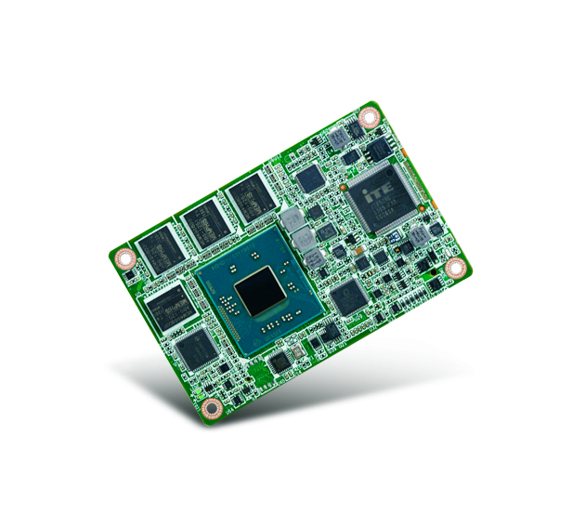
April 15th, 2014, Irvine, CA - Advantech, a leading embedded computing solution provider, announced today the debut of SOM-7567 COM Express® Mini Type 10 module, featuring Intel® Atom™ E3800/Celeron® N2930/J1900 with significant CPU and graphics performance improvements. Measuring only 84 x 55mm, SOM-7567 supports onboard memory up to 4GB and 64GB flash memory, making it a perfect fit for portable applications and rugged requirements.

Significant Upgraded CPU and Graphics Performance
Based on Intel® Atom™ E3800 Family and Celeron® N2930/J1900 processors, SOM-7567 is capable of providing 100% better CPU performance and 5 times faster graphic processing speed than previous generations. The model can support up to 15 simultaneous 1080p full-HD video decode for the surveillance industry which requires multi-displays solution. The upgrade to three Gen 2 PCI express and USB 3.0 enables higher data transfer speeds.

Flexible For Various Product Segments
Featuring business card sized dimensions, SOM-7567 offers high performance with low power consumption. It has wide range voltage input from 4.75 ~ 20V and flexible options from 1 to 4 cores for selection. The small form factor platform makes it suitable for applications in medical, factory, or portable devices. The on-board flash and memory has anti-vibration features, ideally used in rugged solutions for the vehicle or transport market. Better yet, the advantage of graphic processing and media performance makes it excellent for multi display solutions in the surveillance industry.

SUSIAccess Support for Better Centralized Monitoring and Management
SOM-7567 also comes with Advantech SUSIAccess and API bundled for system integrators to centralize monitoring and management of all their embedded devices, and remote recovery if they fail.

SOM-7567 will be available in April, 2014. Please contact your local Advantech sales rep or visit the website (http://www.advantech.com.tw/embcore/) for more details.

SOM-7567 Features:
- COM R2.1 Type 10 Mini Module
- Intel® Atom™ E3800/Celeron® N2930/J1900 processors
- On-board DDR3L and SSD
- Expansion Interface: 3PCIe x1 (Optional 4), LPC, SMBus, I2C, CAN Bus
- Support Embedded Software APIs and Utilities

###

About Embedded Core Service
Advantech Embedded Core Services offers design-in oriented services. These streamlined solutions broadly integrate embedded boards, peripheral modules and software. This dedicated focus on Embedded Design-in services fulfills electronic engineering demands at their design-in phase, and brings benefits that shorten the design and integration cycles, minimizing uncertainty and risk. www.advantech.com/EmbCore

About Advantech
Founded in 1983, Advantech is a leader in providing trusted, innovative products, services, and solutions. Advantech offers comprehensive system integration, hardware, software, customer-centric design services, embedded systems, automation products, and global logistics support. We cooperate closely with our partners to help provide complete solutions for a wide array of applications across a diverse range of industries. Our mission is to enable an intelligent planet with Automation and Embedded Computing products and solutions that empower the development of smarter working and living. With Advantech, there is no limit to the applications and innovations our products make possible. (Corporate Website: www.advantech.com).

