Primary Media Contact:
Advantech Corp.
Edna Garcia
Tel: 949-420-2500, Ext. 134
ednag@advantech.com

Advantech Full Spectrum of RISC-based Computing Powered by Freescale® i.MX6 Processor

June 23, 2014, Irvine, CA – Advantech, a global embedded computing leader is launching a full range of embedded RISC platform solutions powered by Freescale® i.MX6 series processors followed by the ARM® Cortex™-A9 micro architecture. Advantech RISC computing solutions range from ROM-3420 RTX 2.0, ROM-5420 SMARC, ROM-7420 Qseven, RSB-4410 3.5” SBC, UBC-DS31 Compact Signage Player and UBC-200 Network Gateway Box Computer. The Freescale® i.MX6 processor series offers excellent graphic performance, and only 3 watts low power consumption in a fanless design. Advantech RISC computing platforms are ideal for portable, battery-operated and ruggedized applications needing high graphic performance and cost efficiency requirements, such as handheld devices, digital signage, and HMI.

The New Freescale® i.MX6 SoC – Highly integrated, Low Power Consumption
In April 2013, Freescale® unleashed the industry’s first truly scalable multi-core platform that includes single-, dual- and quad-core families based on the ARM® Cortex™A9 architecture. With a highly integrated hardware design and extraordinary graphic performance, the new generation ARM-based SoC has shortened the gap between x86 and RISC and became a simple, cost effective and high performance solution that shakes up the embedded industrial market. By integrating Freescale® i.MX6 series processors, Advantech offers low-cost, simple and flexible RISC computing solutions for customers.

Value-added RISC Hardware and Software Design-in Services
In order to meet the strong demands from industrial markets, Advantech developed a series of industrial-grade solutions with value added services including SW/HW design-in service, schematics review service, and a customization service. To facilitate the integration of

customized applications, Advantech also provides a complete Board Support Package (BSP) and middleware for H/W monitoring, remote management and peripheral control. Moreover, the APIs for vertical markets like signage, automation and IoT are also available to support plug-and-play for RISC Compact Box Computers.
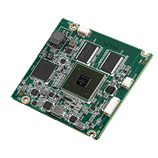
ROM-3420, RTX 2.0 Module (coming soon)
ROM-3420 RTX2.0 module integrates Freescale® i.MX6 Cortex™-A9 1 GHz series ultra low power SoC and I/O solutions, and supports board-to-board 400-pin connectors which provide excellent reliability for ruggedized and military applications. With -40~85 °C wide temperature and wide range power input from DC-in 5V to 24V support, ROM-3420 is an ideal computer-on-module for industrial applications used in rugged environments like automation, vehicle and medical.
(coming soon)
ROM-5420, SMARC Module
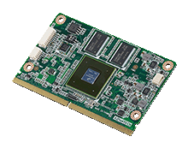
ROM-5420 is an extremely compact size, high-performance and power-saving RISC Computer On Module powered by Freescale® i.MX6 Cortex™-A9 1GHz SoC that complies with the SMARC 1.1 specification. With embedded MCU design, ROM-5420 delivers advanced power management and optimized power quality. It is a solid solution specifically designed for handheld instruments and battery-operated systems.

ROM-7420, Qseven Module
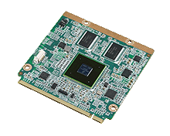
Designed with Freescale i.MX6 Cortex™-A9 1GHz SOLO/Dual/Quad SoC, ROM-7420 is a cost effective solution following the standard Qseven 1.2 specification. With a compact size of 70 x 70 mm, and a light weight of only 20g, ROM-7420 is easy to integrate into various applications and fits different chassis. With multiple OS support for Linux, Embedded Android and Windows Embedded Compact 2013 on a by project basis, ROM-7420 is highly capable for a range of different applications such as industrial control, HMI and transportation.

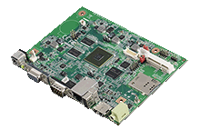
RSB-4410, 3.5” SBC for Multi-media Application
Measuring 146 x 102 mm, RSB-4410 is a full function 3.5" inches single board computer power by the Freescale® i.MX6 series processor. With excellent graphic performance that supports dual Full-HD displays via HDMI, VGA and single channel LVDS, RSB-4410 is a specifically designed single board solution for digital signage. Linux V3.0.35 BSP and Android 4.2.2 BSP are also available for facilitating

application development and system integration. With these features, RSB-4410 is ideal for digital signage and HMI applications.

UBC-DS31, RISC Full HD Digital Signage Box
RISC-based digital signage box UBC-DS31 is powered by Freescale ® Cortex™-A9 i.MX6 Dual 1GHz processor with Advantech signage software built-in. Based on the high performance ARM® Cortex™-A9 processor, UBC-DS31 delivers superior multimedia performance and low power consumption. UBC-DS31 also features an easy assembly mechanical design and built-in plug-and-play UI in Android or Linux-based content editor.

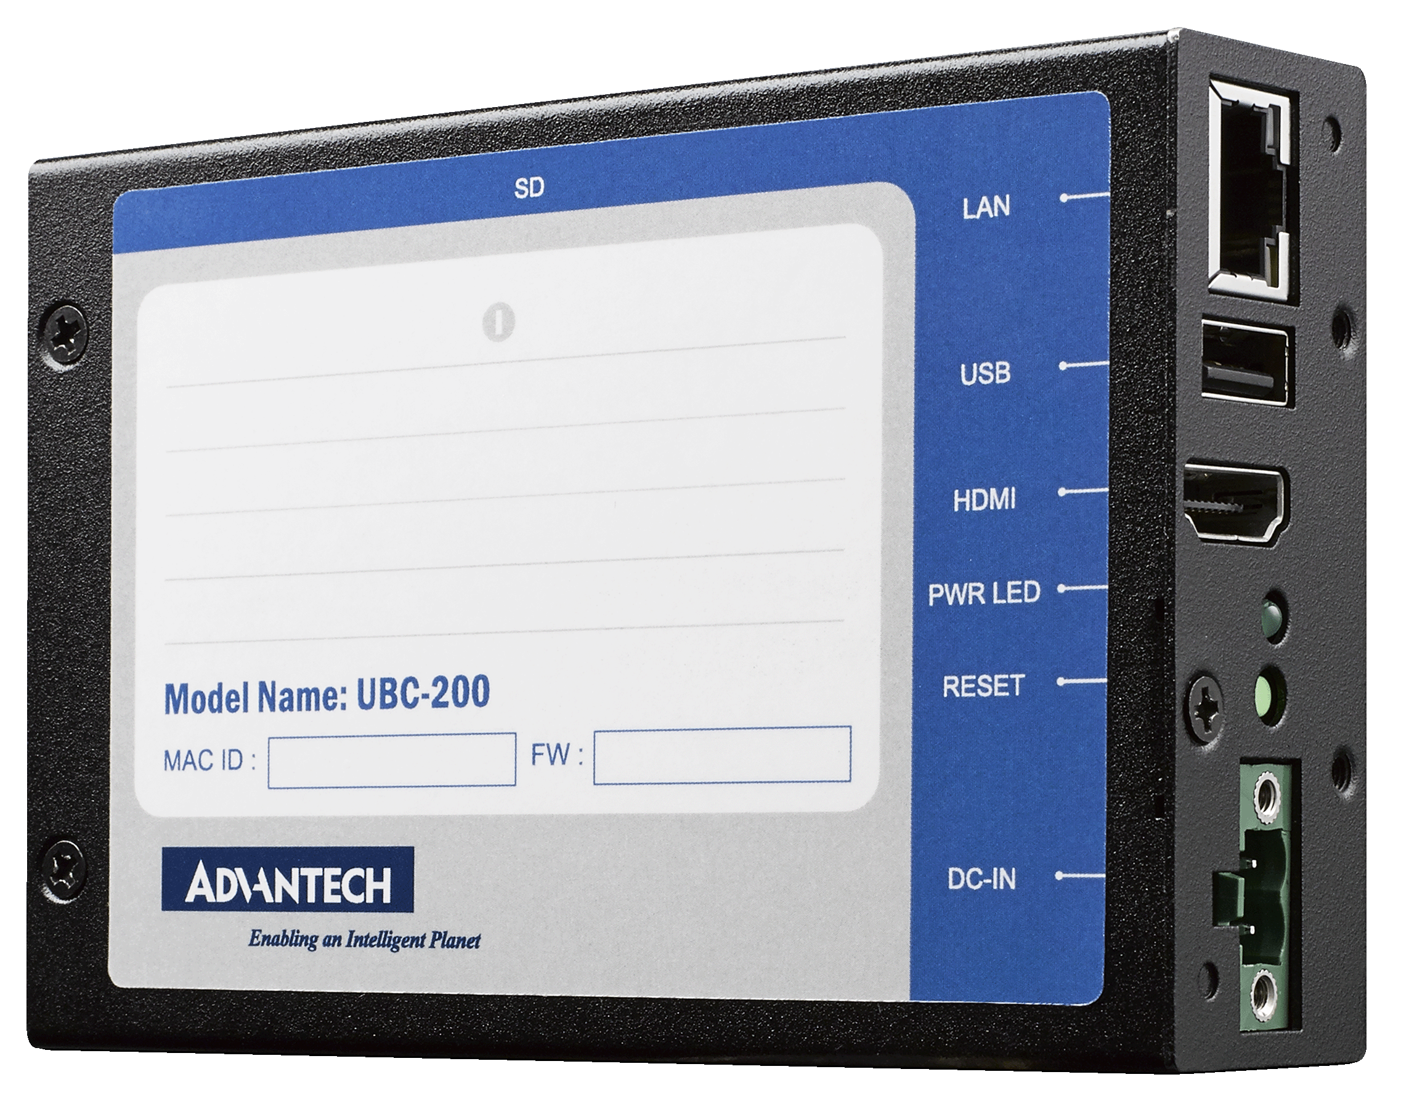
UBC-200, Network Gateway Box Computer
Powered by Freescale® i.MX6 Cortex™-A9 Dual/Quad processor, UBC-200 is an IP-based RISC compact box computer designed for industrial applications and the IoT market. UBC-200 has a compact size of only 111 x 77 x 30mm and multiple I/O including USB 2.0, Full HD 1080P HDMI, Gigabit Ethernet and a mini PCIe slot for WIFI/3G module support. Besides its rich I/O design, it also supports -20~70 °C wide temperature range operation, fanless design for better reliability and wall-mount and DIN rail options for easy mounting.

These new RISC modules, boards and systems come with multi-OS, free BSP, Advantech SUSI API/Middleware and design-in service support. All products will be available by June, 2014.
For more information, please visit www.advantech.com or contact your local sales representatives.
###

About Advantech
Founded in 1983, Advantech is a leader in providing trusted, innovative products, services, and solutions. Advantech offers comprehensive system integration, hardware, software, customer-centric design services, embedded systems, automation products, and global logistics support. We cooperate closely with our partners to help provide complete solutions for a wide array of applications across a diverse range of industries. Our mission is to enable an intelligent planet with Automation and Embedded Computing products and solutions that empower the development of smarter working and living. With Advantech, there is no limit to the applications and innovations our products make possible. (Corporate Website: www.advantech.com).

